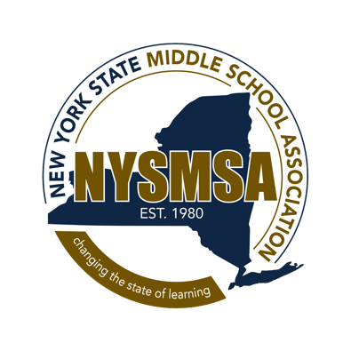 The New York State Middle School Association School Building Membership Application

Please return with payment to:
NYSMSA ■ PO Box 1329 ■ Lewiston, NY 14092
PH/Fax 607-532-4801/4181

Federal ID #22-3105547

Basic School Building Membership $150 (annual rate per building): School receives 3 sets of all NYSMSA publications and member registration rates for all school staff to NYSMSA’s Annual Fall Conference and regional workshops; casts 3 votes in regional elections. Primary contact (listed below) receives membership-related correspondence.

Active Network School Building Membership $500 (annual rate per building): All of the Basic School Building Membership plus: Resource links to timely articles, Invitations for networking with other middle schools, Invitations to contribute examples of Essential Elements in action.

Please indicate: New Renewal

School ____________________________________________________________________________________________

Number of Staff ________________ Grade Range ____________________ Student Enrollment ____________________

Mailing Address ____________________________________________________________________________________

City _________________________________________________ State __________________ Zip __________________

TEL (___)________________________________________ FAX (___)________________________________________

School District _____________________________________________________________________________________

Send Mailings to: | Name | Position | Email
Primary
Name2
Name3

************************************************************************************************** Payment Method (check one):

Purchase Order (enclosed) |  | Check (enclosed, payable to NYSMSA)
Visa |  | MasterCard

For Credit Card payments only:

Credit Card # ________________________________________________________ Expiration Date ________________

Cardholder Zip Code _____________________________________________ Card Security Code __________________

Authorized Signature ________________________________________________________________________________

